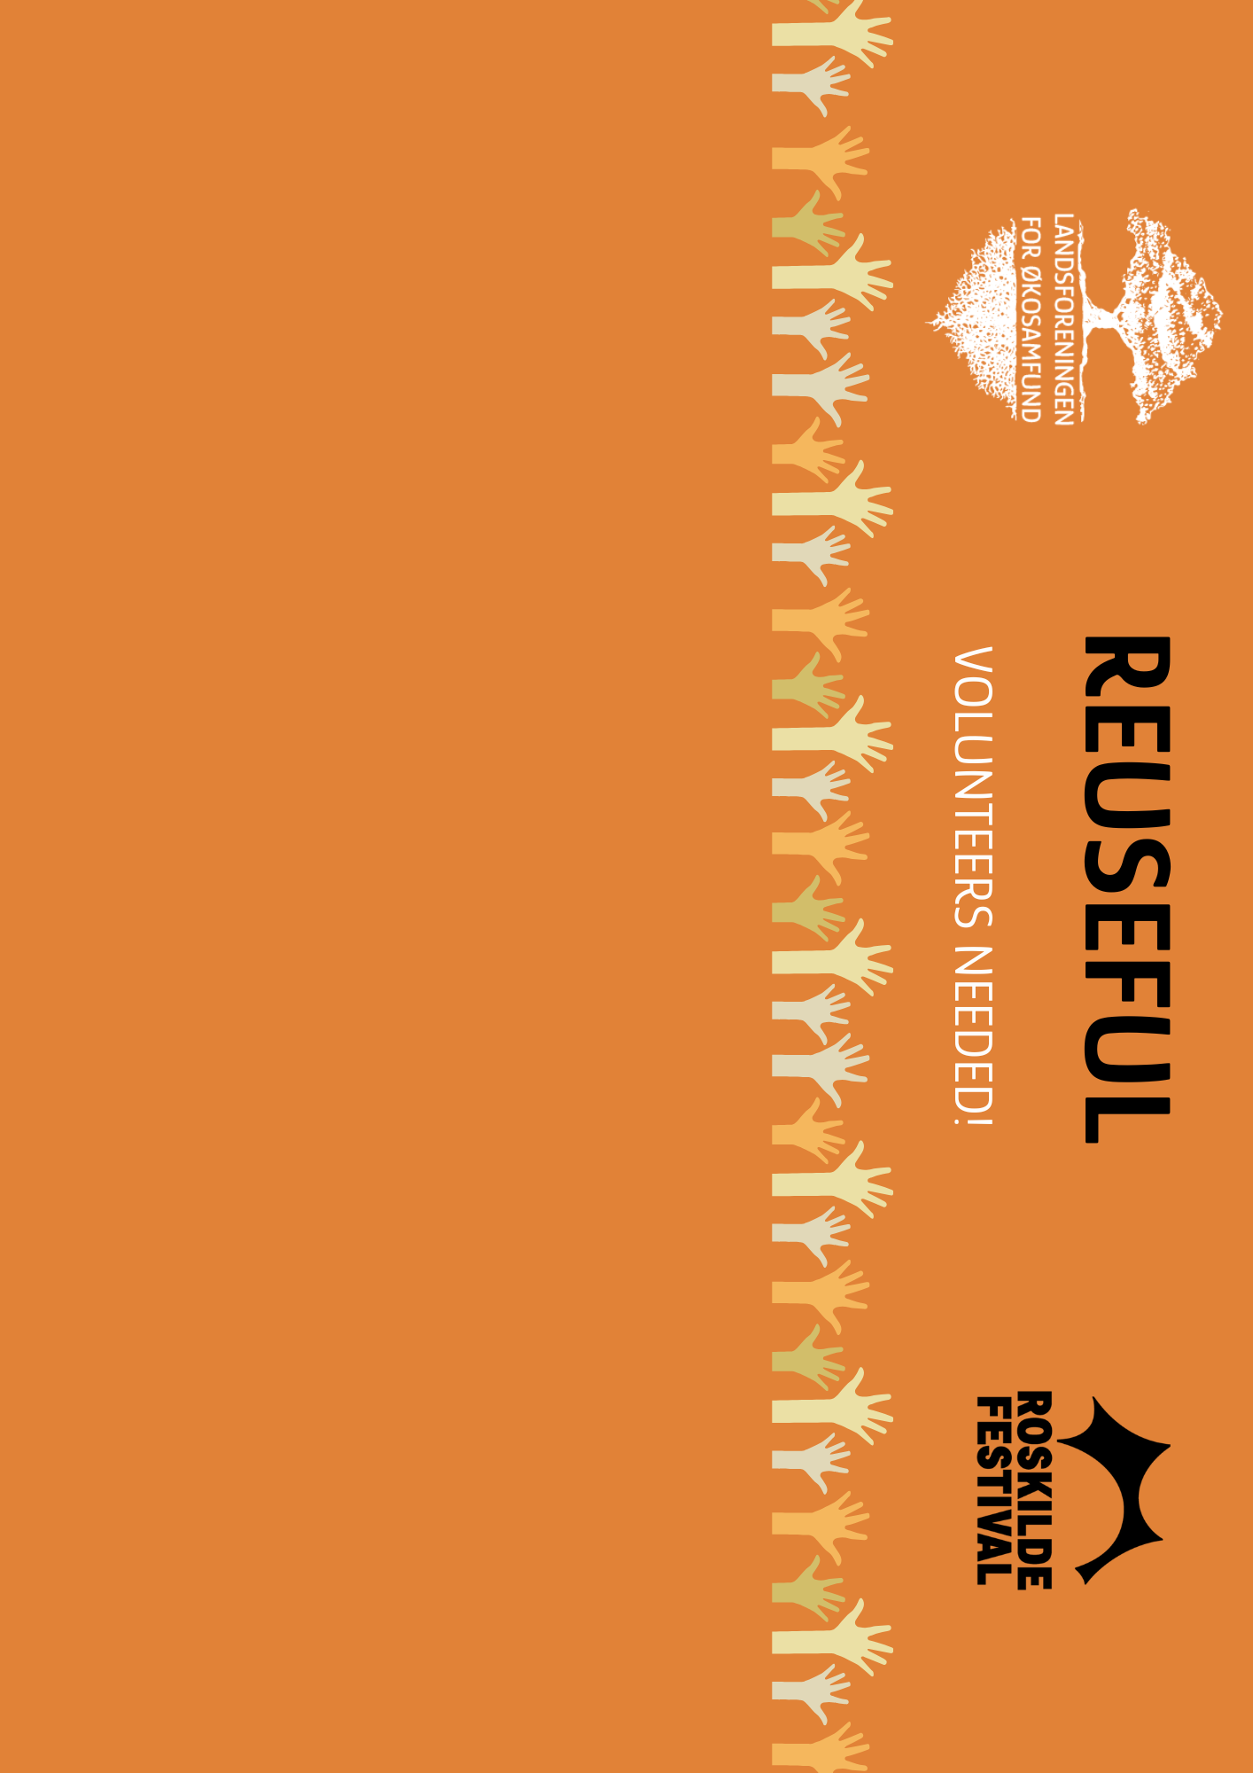

VOLUNTEERS FOR ROSKILDE FESTIVAL
BE A PART OF THE REUSEFUL PROJECT WITH LØS!
Do you want to be part of the ReUseful project at the Roskilde Festival with LØS? We are looking for volunteers from ecovillages.
Our work will take place from Saturday 4th of July, and Sunday 5th & Monday 6th after the festival ends (for a total of 24 hours of volunteering).
The task: We will sort tents, sleeping bags and air mattresses to be reused by NGOs, designers and artists. There is a lot of potential, and we are now looking for around 60 volunteers to help us clean up the campsite. Volunteers have to participate as part of an ecovillage; you cannot participate as an individual.
In addition to entry to the festival and the support provided while working, your organisation will receive 1000 kr per volunteer that it brings.
ABOUT THE LØS VOLUNTEERS
- Around 60 (or more) volunteers in total, with 10-25 volunteers from each ecovillage (or as many as you can get!).
- Volunteers must be part of your ecovillage or people strongly connected to your community.
- Volunteers are expected to be present for all the 24h during the 3 days.
- There can also be helpers = people who don't attend the festival and come along to support their organisation (you don't get money for the helpers).
- Volunteers will be divided to work in different sites of the festival.

VOLUNTEERS AGE REQUIREMENTS
- 18+
- We can accept a few volunteers that are between 15 and 18-years-old but it's limited, as we need ‘adult people’ to reliably work all three days cleaning up.
- You can bring your children below 15 for a reduced ticket price, without them formally having to volunteer as well.
REQUIRED HOURS AND DAYS?
Volunteers involved in the cleanup process must be present on the following days after the festival ends for a total of 24h (division of the hours to be confirmed):
- Saturday 05/07 → 4h (while the festival is still on, setting up)
- Sunday 06/07 → 10h (including breaks)
- Monday 07/07 → 10h (including breaks)

ABOUT THE TASK
- Saving abandoned items that can be reused or repurposed.
- Sort fractions of waste (metal and glass).
- Leave the campsite all clean after the festival.

Everything will be defined and organised later in the process.

WHAT WILL THE VOLUNTEERS/YOUR COMMUNITY GET
- Full access to the festival and to the volunteer camp.
- Financial benefit for your community: 1000* kr per volunteer, paid to your organisation. *There will be a deduction from the money for the food provided during cleaning up days, estimated ~120 kr, tbc.
If a volunteer does not show up to their shifts, their 1000 kr allocation will be deducted from the total the organisation will receive.
- New connections with people from other ecovillages.
- Food on volunteering days (Sunday and Monday).
- A WhatsApp group for volunteers: socialisation and safety at the festival.

CONTACT
E-mail: roskilde@okosamfund.dk
HOW TO APPLY?
Deadline: Tuesday the 1st of May.
Fill out our Google form: https://docs.google.com/forms/d/1pGy7rNYL2idXCYDqmNJXPIQbjq6DPZuPmrzv9ME2TN8/edit

